[E116] Mash temperature sensor

If you see a permanent negative value, zero or 85 °C on the screen, first you have to check if the plug of the temperature sensor is plugged properly into the MCU.

Pull off the indicated hose clamps and silicone tubes from the fittings.

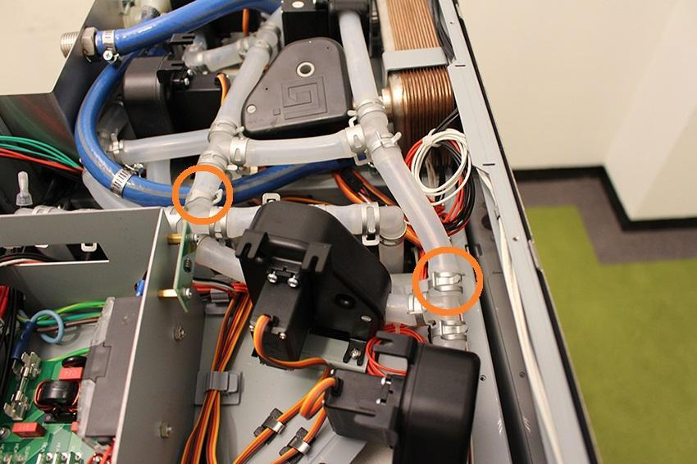

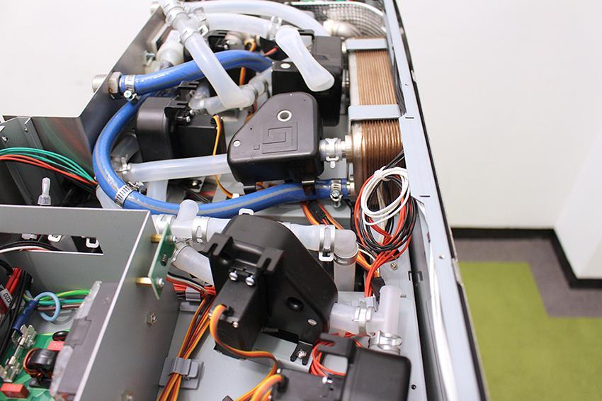

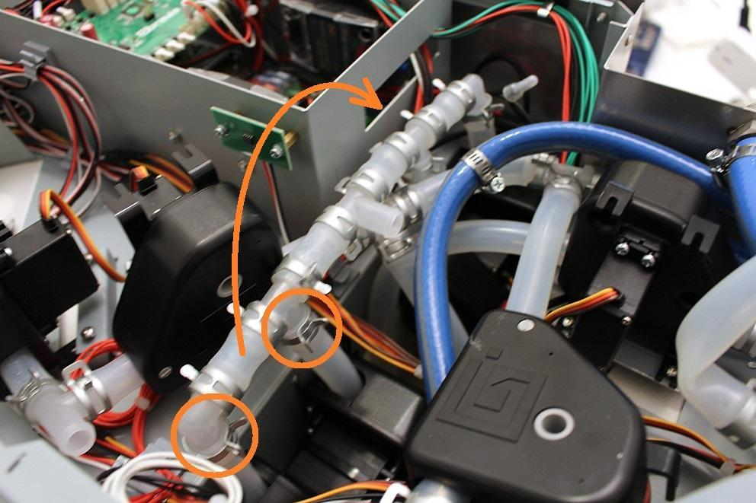

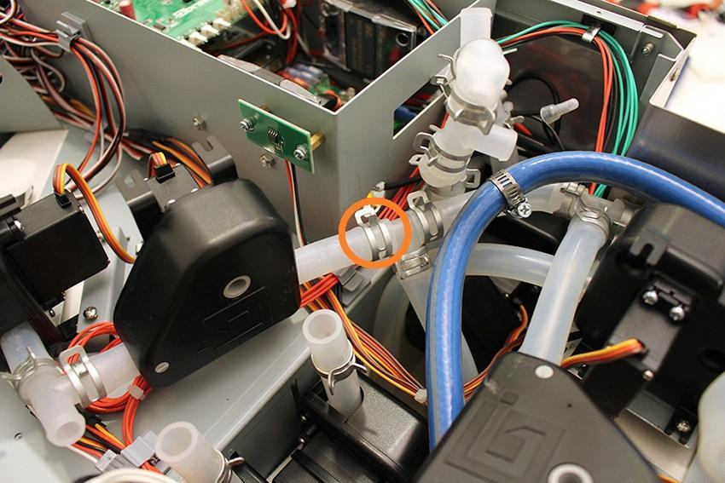

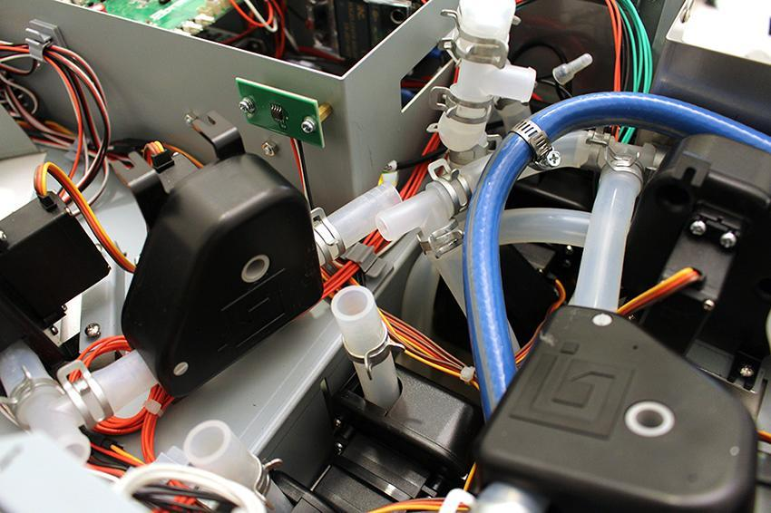

Remove the cable of the temperature sensor from the indicated cable clamps.

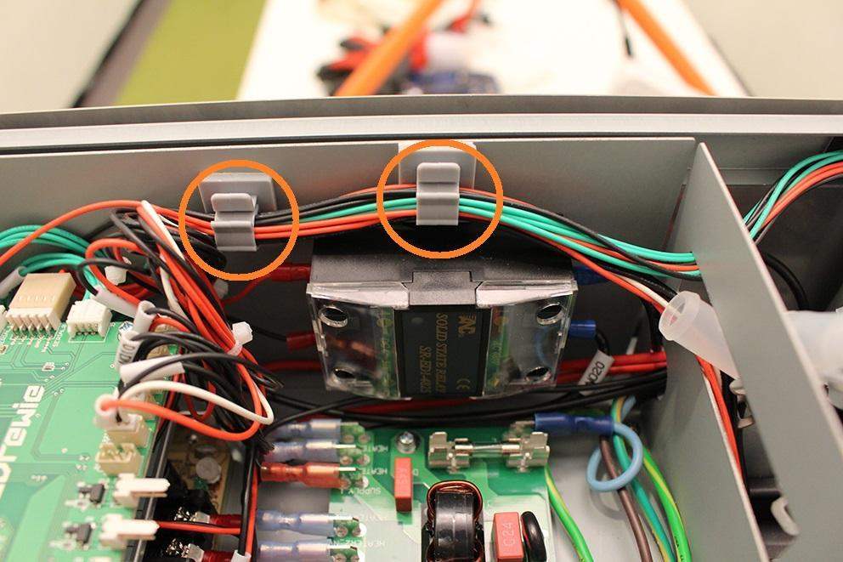

Make sure that both end of the temperature sensor cable is connected properly.

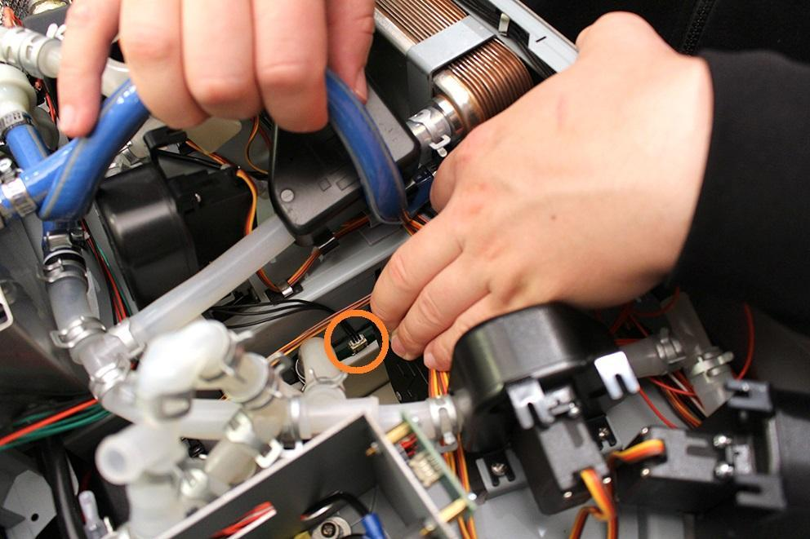

The plug of the temperature sensor cable at the MCU side.

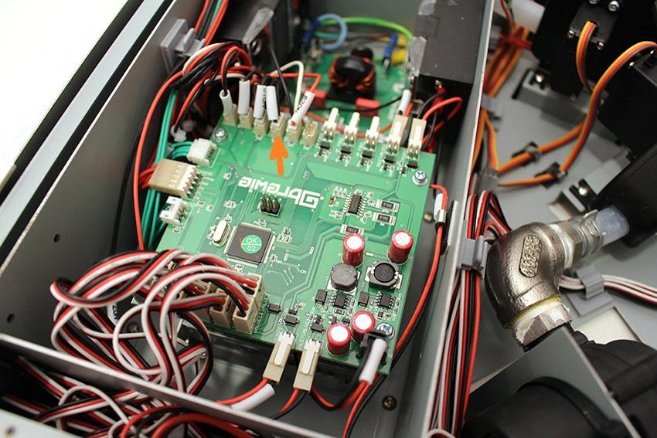

When you’ve made sure that the plugs are connected properly and you see permanent negative value, zero or 85 °C on the screen again, please contact Brewie HQ.